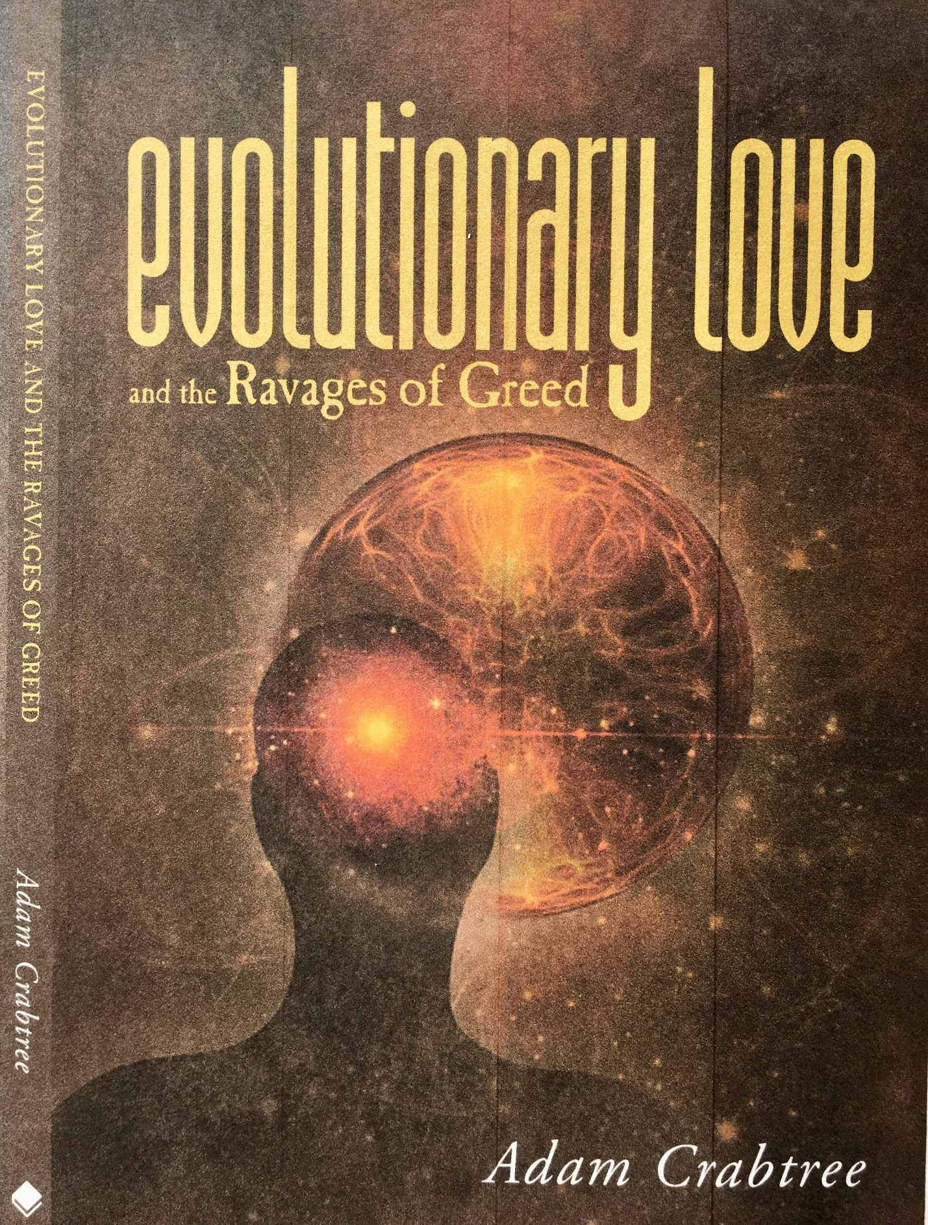

evolutionary love

and the Ravages of Greed

Adam Crabtree

Adam Crabtree’s new book Evolutionary Love and the Ravages of Greed, is available at all the usual online booksellers (Amazon, etc) and in all the major iReader formats.

Friesen Press
Suite 300 - 990 Fort St
Victoria, BC, V8V 3K2
Canada
www.friesenpress.com

Copyright © 2017 by Adam Crabtree
First Edition — 2017
All rights reserved.

No part of this publication may be reproduced in any form, or by any means, electronic or
mechanical, including photocopying, recording, or any information browsing, storage, or
retrieval system, without permission in writing from Friesen Press.

ISBN
978-1-5255-0967-4 (Hardcover)
978-1-5255-0968-1 (Paperback)
978-1-5255-0969-8 (eBook)
1. BISAC code 001

Distributed to the trade by The Ingram Book Company

Acknowledgements

I would like to recognize first the important role played by Jim and Christina Grote in the writing and publishing of this book. They have encouraged me at various stages of my work and offered important feedback on the content. They have also promoted its publication with moral and financial support.
Numerous other people have provided valuable responses to my writing as it progressed. I would like to make special mention of Robert Corrington, who encouraged and inspired me in various ways. I would also like to thank Matthew Ahern, Pam Kramer, Julia Mossbridge, Karin Porter, and Eric Robertson for reading the manuscript in the course of its evolution.

A special word of thanks goes to my son, Andrew Crabtree, whose philosophical insights and editorial input have been invaluable.

Finally, I am most grateful to Mike Murphy, who encouraged my early investigation of Peirce and expressed strong emotional support for my attempt to say something significant about love.

Table of Contents

Acknowledgements . . . . . . . . . . . . . . . . . .. . . . . . . . . . . . v
Introduction . . . . . . . . . . . . . . . . . . . . . . . . . .. . . . . . . . . . .ix

Part One: Love. . . . . . . . . . . . . . . . . . . . . . . . . . . . . . . . . . . 1
Chapter 1: Love. . . . . . . . . . . . . . . . . . . . . . . . . . . . . . . . . . 3
Chapter 2: Love in Action. . . . . . . . . . . . . . . . . . . . . . . . 51

Part Two: Greed. . . . . . . . . . . . . . . . . . . . . . . . . . . . . . . . . 65
Introduction . . . . . . . . . . . . . . . . . . . . . . . . . . . . . . . .. . . . 67
Chapter 3: Global Greed . . . . . . . . . . . . . . . . . . . . . . . . 71
Chapter 4: Institutionalized Greed. . . . . . . . . . . . . . . 83

Part Three: Agape And Human Evolution . . . . . . . 101
Chapter 5: Agape And Hope. . . . . . . . . . . . . . . . . . . . 103

Epilogue:
A Personal Note on Optimism. . . . . . . . . . . . . . . . . . 119
Bibliography . . . . . . . . . . . . . . . . . . . . . . . . . . . . . . . . . . 123
Index. . . . . . . . . . . . . . . . . . . . . . . . . . . . . . . . . . . . . . . . . . 127
Notes. . . . . . . . . . . . . . . . . . . . . . . . . . . . . . . . . . . . . . . . . . 129

Introduction

Greed dominates our world today. We see it at every turn in its societal, political, institutional, and individual forms. We sense that greed means a lack of love. But just how greed relates to love and how love can counteract its effects may not be all that clear. Because of its powerful influence in our world, I offer this book as an attempt to fathom the essential meaning of greed and, more importantly, to explore the fundamental power of love to end its dominance.

In the Netflix series House of Cards, the unscrupulous protagonist, Francis Underwood, tells us that greed is either greed for money or greed for power. He despises those who exercise greed for mere money, which he considers a base and less intelligent form of greed. Underwood sees the core meaning of greed as the attainment of power and is convinced that if one concentrates his or her efforts on accumulating power, money will take care of itself. He also believes those who concentrate on money narrow their perspective and thereby become vulnerable to manipulation. The view of greed in popular culture tends to emphasize the money aspect, as we can see for instance, in the CNN series on The Eighties, which describes that period as the decade of greed and the Wall Street manipulator as the wizard of greed. Those infected by greed for money, whether they be rich or poor, reduce the world to economics. Those who espouse greed for power reduce the world to politics. I believe Underwood’s view of the core nature of greed is closer to the truth. Greed is the insatiable and unrestrained desire for any means of self-enhancement.

Greed for power can take many forms, from a despotic leader’s domination of a country to a petty mobster dominating a neighborhood. The classic film Key Largo includes a scene that portrays naked greed in a striking way. Rocco (Edward G. Robinson) is a mobster of the worst kind, sadistic and ruthless. Frank (Humphrey Bogart) is a veteran and a hero, just returned from the war. James Temple (Lionel Barrymore) is the owner of the hotel taken over by Rocco and his thugs. The following dialogue occurs when Temple asks Rocco what he wants for himself:

Frank: He knows what he wants—don’t you, Rocco?
Rocco: Sure.
Temple: What’s that?
Frank: Tell him, Rocco.
Rocco: Well, I want . . ..
Frank: He wants more. Don’t you, Rocco?
Rocco: That’s it! More, that’s right! I want more!
Temple: You’ll never get enough, will you, Rocco?
Rocco: Well, I never have! No, I guess I won’t!
Greed is insatiable. Whether one seeks power, influence, money, land, consumer goods, food, sex, fame, preferential treatment, control—greed always wants more.
I see the domination of the world by greed today as a defect in the exercise of love. In fact, I describe greed precisely in those terms, as the unconstrained desire for any sort of enrichment. For that reason, it is impossible to fully expose greed in our world and explore the possibilities of opposing its dominance without first talking about love in its essential meaning.

Philosophy, when just escaping from its golden pupa-skin, mythology, proclaimed the great evolutionary agency of the universe to be Love.
—Charles Sanders Peirce

The great American philosopher, Charles Sanders Peirce, believed that love was central to the existence and functioning of the universe. He saw one kind of love in particular as the driving force behind the development and fulfillment of all things. This is what Peirce called “evolutionary love.”
I first spoke publicly about this idea in 2012 at an Integral Transformative Practice workshop in San Francisco. I had been studying Peirce’s work and became intrigued by a little treatise he wrote in 1893 for a periodical called the Monist. He gave it the striking title “Evolutionary Love,” and from its opening words, he adopted a tone very different from that of his other writings. It feels like a demand for the reader’s attention, a summons to pay heed to a message of crucial importance. I felt drawn to the powerful flow of ideas, and as I read, a compelling vision took shape for me. The more I was immersed in the piece, the more puzzled I became that this remarkable manifesto had almost completely escaped the notice of those engaged in exploring the fundamental nature of the world and the meaning of human life.

If you had Googled the term “evolutionary love” in 2012, you would have found few responses: only direct references to Peirce’s article and citations of that piece by philosophical scholars. Now, five years later, it is popping up all over the place. There seems to be a sense that something of great value is hidden in the conjunction of those two words, something that responds to the current urgent need to understand, on the deepest possible level, the disturbances that trouble the modern human community.

After that talk in 2012, I developed my initial ideas and made them available in certain online scholarly repositories of current academic work. Most recently, I have referred to evolutionary love in the final chapter of my book, Memoir of a Trance Therapist, and in a chapter in Beyond Physicalism. In the meantime, I became convinced that evolutionary love deserves a more thorough treatment than I have given it so far.

In Peirce’s article, penned more than a century ago, he presented certain novel, richly evocative ideas. He argued that love is a philosophical principle that is fundamental to understanding not only human interactions and strivings but also the very constitution of the universe. Peirce, however, introduced a new perspective on the ancient theme, presenting love as the engine that drives all evolution: human and cosmic. He defined this love as “the ardent impulse to fulfill another’s highest impulse” (CP 6, 289), which, taken in its broadest meaning, is the desire that loved beings reach their greatest possible development, the fullest actualization of their potentials. Put in more modern language, it is the unconditional desire that the object of love achieve its greatest possible evolutionary fulfillment.

He contrasts this view of evolutionary growth with the strife of the Darwinian approach, which explains everything through natural selection and survival of the fittest, and the mechanistic view of determinism, which posits a world with a completely predetermined future. Peirce recognized that both approaches make valid contributions to our understanding of the mechanisms of evolution, but he insisted that something more was needed to offer a full explanation for evolution as it actually functions in our world. To provide an adequate vision of evolution, he introduced the notion of a beneficent, foundational evolutionary force, a selfless love that—following the lead of the Gospel of John—he called agape, in contrast with the self-focused love characterized by desire that the Greeks called eros.

For Peirce, evolution was not merely a matter of biology. Based on a profound metaphysical view of reality, which he derived from a scientifically grounded empiricism, he held that everything evolves. Furthermore, he held that human beings have a unique position in nature, being able to contribute consciously to their own evolutionary advance through participation in evolutionary love and possessing the power to make free choices that have real effects on the evolution of the universe.

Disappointingly, Peirce did not develop this striking evolutionary panorama as far as one might wish. It is my intention to elaborate and expand upon Peirce’s vision, suggesting a view of the nature and direction of the evolving cosmos that has practical consequences for the determination of right action for individuals and human communities.

In this book, I propose a view of love that can be expressed in three ideas: 1) Two loves form the foundation for cosmic and human evolution: benevolent love (agape) and desire love (eros). 2) Our dealings with each other and the world involve a mixture of these two loves, and if our actions are to honor the fundamental nature of things, benevolent love must be given primacy over eros in our moral choices. 3) If that primacy is violated, and eros dominates, the result is a greed for power or wealth that corrupts basic values and blocks the great project of humankind: the promotion of evolutionary advancement and the discovery of truth.

The widespread turmoil in the human community today is a symptom of the dominance of un- checked desire, or Greed. This book distinguishes two ancient concepts of love (the Greek ideas of agape and eros) and explores how agape, the driver of evolution, when put into play through the harmonious action of eros, displays the true essence of love – Evolutionary Love– that alone is the antidote to the ravages of Greed.

“In this beautifully written and profound work, Adam Crabtree engages in phenomenological descriptions of: several types of community, the intertwining of eros and agape, the current victory of greed in the church and the university, the use of psychodynamic and psychoanalytic insights, and the prospects for the future of agape. His distinctions between eros and agape go beyond the shop worn polemics of some traditions and comes out on the side of agape as it provides the encompassing ground for eros. Using C. S. Peirce’s notion of “evolutionary love,” Crabtree goes beyond Peirce’s formulations and evokes agape in much richer ways. Like Peirce, he sees agape as a cosmic force, not merely something humans can achieve on a rare occasion. Agape permeates all of the cosmos and gently moves humans to post-tribal thinking. Yet eros is not slighted or cast in a demonic light. Quite to the contrary, Crabtree shows the utter value of eros in its drive for connectedness and a rich life. He displays his own clinical material to enhance his conceptual framework and this adds grounding to the work as a whole. Finally, he applies psychological insights into communal and social behavior, thus going beyond a one-sided focus on the individual.”
--Robert S. Corrington, Henry Anson Buttz Professor of Philosophical Theology, Drew University

“This is a gem of a book with many glistening facets. From one angle, it is a philosophical primer on unconditional and erotic love and how these drive biological, cultural, spiritual, and, ultimately, cosmic evolution--Dante’s love “that moves the sun and the stars.” From another angle, the book is a reflection on the power of trance as both the psychosomatic means to access extraordinary human capacities and creativity, but also as the primary mechanism of social, economic, and religious control. From another angle still, the book reveals a world awash in signs, meaning, and purpose, whose human interpretation literally and truly evolves both the world and us. Adam Crabtree is our moral conscience and ethical guide here, but also our cultural trance-breaker and our practical guide to a new (and yet very old) practice—the practice of actualizing human potential.”
--Jeffrey J. Kripal,
author of Esalen: America and the Religion of No Religion

“Adam Crabtree has given us a thoughtful, original, nuanced, and both philosophically- and psychologically-wide-ranging exploration of the two basic forms of love--agape and eros, emphasizing the primacy of the former and its critical role in the advancement of humankind. At the same time, his book is also a valuable contribution to the study of philosopher Charles Peirce. Crabtree’s discussions of the varieties of greed and the manifestation of greed in the group mind of religious institutions are especially penetrating. And his trenchant critique of institutions of higher learning is especially timely.”
--Stephen Braude,
Emeritus Professor of Philosophy, University of Maryland

